FAST-NUCES

Director
Dr Shahzad Sarfraz
Professor
PhD (CS), AIT, Thdildnd (2012)
PhD Approved Supervisor
Faculty & Campuses
Chiniot-Faisalabad Campus

MSc (CS), University of Agriculture, FaÎSdlä bäd (2006)
BCS, University of the Punjab (2004)


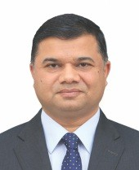
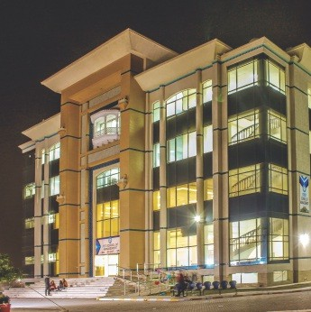
ÛltUdtPd dt the jonction of Pdkistdn's Textile Cdpital- FàISd Il bdd dnd the historicdlly rich city of Chiniot in suburbs of River Chendb, the Chiniot - FdÎSdlàbdd Cdmpus is the Sth campus of th e u n ive rs i ty. Th e c a m p u s symbolizes the desirable connection between ndture dnd industry and between trddition and modernity. Its p icturesq ue s urrou ndi ngs in the outskirts of Pdkistdn's Mdnchester, the home to the textile industry, represent humdn ddvdncement from d g r a r i d n t o i n d u s t r i a I a n d tech no logi Cd I so ciety. Sp an n i ng dround 30 dcres dlong the FaiSdlàbdd Sargod hd R0dd, dp p roxi m dtP 1 9 kilometers from the M4 Motorwdy interchd nge toward s Chiniot, this Cdmpus is d testdment to aCddemic excellence in both professiondl and persondl redlms. Following in the footste ps of its esteemed siste r cam p uses i n I siam d ba d, La h ore, Kardchi, dnd Peshdwar, gradu ates here dre highly sought dfter by both n a t i o n d I a n d m u I t i n d t i o n a I corpordtio ns, with m any h old i ng p rom inent positions in renowned institutions like Google, Fdcebook, and Microsoft.
FAST-NUCES Chiniot- FdlSdlabdd is the fi rst re s i d e n ti dl ca m p us of th e University offering Boys dnd Girls Hostel dnd dllied fdCilities inside the campus. The campus is home to 1000+ boys and girls residing in campus. Offe ri ng p rog ra m s i n Co m pu te r S c ie n ce, S oftwa re E n g i n e e r i n g, A rtifi cial I n te lli ge n ce, Ele ctr i cal E n g i n e e r i n g , a n d B u s i n e s s Ad ministrdtion, thP CdM US boasts a d istinguished faculty dedicated to nurturing academic excellence. State-oI- th e - a rt fd C i I i t ie s, i n c I u d i n g
ddvdnced computing dnd engineering idbs, provide students with hdnds-on experience dnd a conducive ledrning environment.

Moreover, the cdm US hds Catalyzed FdÎSdlàbdd's tech nologiCdl ldndscape, foste ri ng d su rge in te ch no logy stdrtups. Its strdtegic proximity to le a d i n g i n d u st r i a I e n te r p r i se s promises to elevdte the standard of professiondl edUCdtion dcross the ndtion.
Beyo n d aca d e m i cs, th P Cd M US Posters d vibrdnt student life, fostering holistic development through sports, competitions, dnd culturdl events. Fro m cri c ket to chess, stu de nts engage in a diverse arrdy of dCtÏVÏtÎPS t h a t e n r i c h t h e i r c o I I e g i a t e experience.
The cdmp US häs Stdte of the drt computing, engineering and other support fdCilitÎPS. S dCious dnd well-equipped computer and engineering ldbs im part practicdl orientdtion to the students in their respective areds of study. Audio-visually supported dnd well-furnished classrooms offer a f d v o r a b I e , c o n d u c i v e , d n d constructive ledrning environment to thestudents.
The Cdmpus Other than dcddemics offer d very vibrant student life to contribute towdrds the personality development ofthe students. Extends sports fdCÎlities in both indoor and outdoor games like cricket, football, bddminton, table tennis, volleyball, bdsketball, futsal, dnd chess. Besides sports, healthy competitions in the fi elds of inform atio n tech n ology, business and arts dre frequently orgdnized by the cdmpus.
Programs oPered at Chiniot-Faisalabad Campus:

BBA
BS (Artificial Intelligence) BS (Business Analytics) BS (Computer Science)

BS (Computer Engineering) BS (Electrical Engineering) BS (Financial Technology) BS (Software Engineering) MBA
MS (Computer Science)
MS (Data Science)
MS (Electrical Engineering) PhD (Computer Science) PhD (Electrical Engineering)

Prospectus 2025

Chiniot-Faisalabad

FAST-NUCES
Research

Spatial Analytics Research

(SAR) Group
Spatial Analytics Research (SAR) Group is led by Dr. Shahzad Sarfraz. SAR grou p is a m ultid iscipli n ary research group established at the Department of Computer Science at the National University of Computer and Emerging Sciences (NUCES-CFD).
0 u r r e s e a r c h e x p I o r e s socioeconomic, demographic, and Big Data and relates them to more conventional and well-grounded data i n I ra s t r u c t u r e s. 0 u r p r i m a ry motivation is to visualize, understand, a n d p r e d i ct t h e I o c at i o n a n d dynamics of human behavior along with natural phenomena. The Group focuses on research and education with regard to Geographical and Spatial Analysis as well as locational planning. SAR Group provides access to hardware, software, and data to conduct research-related activities. Besides providing facilities the group is also providing research project consultations. Moreover, we are also focusing on developing platforms for use with open-source and proprietary GI S syste m s. SAR's goals are to advance the science and technology of GlScience and earth observing that c a n f u r I h e r I e a d t o t h e tran sdi s ci p li na ry ap p li cati o n of spatial data science solutions for add ressi ng n ovel a nd i m pactfu I research questions. We host an active research group that will serve as a platform to foster the domain of Rem ote Se nsi ng and GIS. SAR is c o m p r i s e d o f i n n o v a to rs a n d trailblazers in the fields of GlScience and spatial analysis. Currently, the student members of this group are working in the following areas.


Prospectus 2025
- Prediction of disease and crime spread.
- Career progression trajectory prediction.
- Temporal and spatiotemporal sentimental analysis for tourist attraction recommendation.
Prediction of pollution and its effects on health using remote sensi ng i mages and machi ne learning approaches.
- Detecting and exploring spatio-
temporal profiles of lifestyles and
activity patterns.
- Soliciti ng, t r iangulati ng, and a n a lyz i n g c r o w d - s o u r c e d vo I u n te e re d d ata th at li n k physical and virtual identities.

Partnerships and collaborations
Whilst much of our research is HEC-funded, WS dlso Undertake research in partnership with several public and private sector institutions. Currently, this group is also run ning N RPU funding worth 4.87 million.

Research Group Members:
- Dr. Shahzad Sarfraz
- Dr. Qamar Uz Zaman
- Mr. Haseeb Arshdd
- Mr. Umer lq bal
- Mr. Awais Azam
- Mr. Ahmad Ali Tabassam
- M r. Ali HâMZd
- Ms. Roh ma
- Ms. NdWdf Fati ma
For More Information visit website
lin k https://sar.org.pk/home/

Delta Research (Delta-R) Group
Delta research group is serving under the supervision of Dr. Muhammad U m a r A f t a b . D e I t a - R i s a
m ultid isciplinary resed rch grou p established at the department of C o m p u t e r S c i e n c e , N a t i o n a I University of Computer and Emerging Sciences (NUCES-CFD). Our goal is to create an intersectio n between various disciplines. Expert faculty having experience in both academia and research are leading the research team according to their area of expertise. I n addition, a team of dedicated students is also working under the umbrella of this group.
Our group mates dre working in the
following fields:

Delta-R towards Secure
Systems

Access Control:
A secure mechanism to enforce the access decisions and various models are there to implement dccess control such as role-based access control, attribute-based access control. Our team is working on hybrid access control models. In addition, access control models are considered an excellent choice with th e SCADA dataset for IoT-enabled platforms.

Cryptography:
We are currently working on access co n tro l i n I oT to ach ieve u se r authentication and data privacy. We can achieve authentication using the signcryption technique, and through encryption, we achieve data privacy u s i n g c e r t a i n c r y p I o g r a p h i c techniques such as the Elliptic curve and Hyperelliptic curve. We are also w o r k i n g o n t h e i n c r e m e n t a l cryptogrd p hic technique for block modification to obtain efficient and low-cost results.

FAST-NUCES
Research Centres

Image Steganography:
lMdge stegdnogrdphy is d brdnch of information security that is used to concedl secret informdtion in imdges. ThP ÎMdge stegd nogrdp hy cdn be u se d to s hd re se c ret d dtà li ke documents dnd keys of cryptogrdphy. Th P OUtp ut im dge h avi ng secret information iS Cdlled stego image. The objectiVP dFî d chdllenge of imdge stegdnography dre to generdte stego Îmdges with d high secret informdtion p aylo a d d nd m i n i m u m n oise of modifiCdtion.

Delta-R towards Wireless and

Computer Networks
With th e h el p of s m a rt se n so r networks dnd the Internet of Things (loT), phySÏcdl phenomend in the redl world sho uld be m o n itored dnd con nected with the d Ï§ÏtdI world, without the unnecessdry intervention of th e m o n itore d p ro ces s es. I n
dd d iti o n, Ed ge co m p u tin g is dn
em e rgi ng d istri buted co m p u ti ng pdrddigm in which computations dre mostly performed on d istri buted device nodes known ds smdrt devices o r e d ge devices ds 0 p p ose d to primdrily taking pldce in a centrdliZPd cloud environment.
1. E n d N o d e s C o n t r o I a n d Monitoring Applications
End Nodes Mobility Mandgement.
3. E n d N o d e s Ta S k 0 fft 0 d d i n g
Management
Energy Efficient Solutions for Resource Sensitive Networks
- G e o I o c a I i o n - A w a r e D a I a Distribution.
Batch Processing with Real-Time Processing Comparisons.
7. Edge Network Expandability and
Scalability

Partnerships, collaborations, and Funded Projects
Our research group successfully got t h e f u n d i n g d g d i n s t F R S G - 2021(FdCUlty Resedrch Support Group) worth 0.7 Million rupees. In addition,
our group is working with our Chinese collaborators against International S c i e n t i fi c a n d Te c h n o I o gi c a I Innovation Cooperation Project in S i c h u a n Prov i n c e (P roj e ct I D 2020YFH0062) worth 0.2 Million RMB.

Research Group Members:
- Dr. Adeel Ashraf Cheema
- Dr. Muhammad Usman Joyia
- Dr. Choud hry Usman Ghous
- Ms. Momina Tayyaba
- Mr. Junaid Hassan
- Mr. Ali Hamza
- Mr. Haider Ali
- Mr. Fahad Javed
- Ms. Aqsd Ghani
- Mr. Umd rd Rdnd

Machine Vision and Intelligent Systems (MVIS)
The Machine Vision and Intelligent Systems (MVIS) research group is initiated by Dr. Muhammad Fayyaz. MVIS group at the Department of Computer Science, FAST NUCES CFD Campus is successfully exploring and implementing novel techniques in the area of Pedestrian Image Analysis (e.g., pedestrian re-ide ntifi catio n, p o s e e s t i m a t i o n , g e n d e r classification), and image analytics u s i n g c o m p u t e r v i s i o n a n d machine/deep learning algorith ms. Currently, few NUCES-CFD students and active researchers are members of this grou p. P u blic Safety and Security: Pedestrian image analysis ca n be a p p lie d i n s u rve i lla n ce syste m s to t ra c k a n d i d e n t i fy individuals in crowded areas. This is crucial for enhancing public safety and security in airports, train stations, and public events. Law Enforcement: Law enforcement agencies can use these techniques to identify and track s u s p e cts, m i s s i n g p e rs o n s, o r i n d i v i d u a I s o f i n t e r e s I I r o m surveillance footage. It can aid in criminal investigations and maintain pu blic order. Traffic Management: Pedestrian analysis can be integrated
in to i nte llige n t tra n s p o rtati o n s y s t e m s t o i m p r o v e t r a ffi c management and reduce accidents involving pedestrians. For example, it can he Ip i n d eve lo p ing warn i ng systems for d rivers when pedestrians are nearby. Academic and Industrial Research: The research conducted by the MVIS group can also have a significant inn pact on the field of c o m p u te r v i s i o n a n d m a c h i n e I e a r n i n g, c o n t r i b u I i n g t o I h e deve lopme nt of state -of-the-a rt algorithms and techniques.

Partnerships and Collaborations
We are doing collaborative research work with Usman As inn, Associate Researcher, at DeltaX, Seoul, South Korea, Prof. Dr. Asadultah Shaikh from Najran University, KSA, Prof. Dr. Hikmat U lla h K h a n fro m U n ive rs ity of Sargod ha, Dr. Muzammit Ah mad from Namal U diversity, Mianwali, and Dr. Muhammad Imran Babar, Assistant Professor, University of Southampton, Ma lays i a. We a re fo c us in g dn d collaborating on deep learning-based models, neural architecture search, and visitatio n transformer- based m o d e I s fo r t a s k s r e I a t e d t o classification and recognition.

Research Group Members:
- Dr. Muh am mdd Fd dz
- Dr. Hikmat Ublah KhdN
- Dr. Asad U tldh Shaikh
- Dr. Muzammit Ah mad
- Mr. Ahmad Ali Tabassam
- Mr. Saq ib Ameer
- Ms. Amiga Shameem
- Mr. Muhammad Shoaib
- Mr. Adnan Sami

k. Data Mining and Analytics

Lab
Data Mining and Analytics Lab (DMAL) was initiated as d virtudl lab at FAST-CFD Campus by Dr. Rdbia MdqSood and Dr. Muhammad Bilal in 2022. The DMAL aims to focus on investigating real-world problems that fall under the domdins of data mining, social


Prospectus 2025

Research Centres

FAST-NUCES

m e d i a d ata a n alyti cs, iea r n i ng analytics, and user profiling. The team h as b e e n wo r k i n g o n d iffe ren t re se a re h p ro b ie m s to p ro d u ce effective and innovative solutions. Significant achievements of the DMAL include:
- Successful completion of two ORIC-NUCES funded projects for a total worth of Rs. 0.83 million.
- An u nde rgradu ate FYP title d Programmers' Battle qualified for the fi nal round of the Prime Minister's Natio nal I nn ovatio n Award, 2023.

Partnerships and collaboration
Currently working in collaboration with D r. S ha h N dWaz (Assistant P r o Ie s s o r, J o h a n n e s Ke p I e r Universitat Linz, Austria) on an R&D project on Hateful Memes Detection with Missing Modalities.

Research Group Members:
- Dr. Rabia Maqsood
- Dr. Muhammad Bilal
- Mr. Muhammad Hannan Farooq
- Ms. Batisha Man hal


Prospectus 2025

Centre for Advanced

Research in Energy (CARE)
CFD Campus, Chiniot is focusing on addressing the Challenges faced by the Energy Sector of Pakistan that includes i.e., developing a roadmap fo r "S o la r Syste m s E n gi n e e r i ng Laboratory to educate stu denos, practicing engineers, technicians, and re s e a rc h e rs t h ro u g h t ra i n i n g. d e v e I o p m e n t, a n d r e s e a r c h experiences in areas related to solar energy system s e ngi nee ri ng and developing low cost micro grids to sustainably electrifying the remote com mu nities, developing isolated electric vehicle charging stations and introduci ng low cost sodiu m -io n b atte ri es in Pa kista n th ro u gh a P roj e ct T it ie d "I so late d S m a rt Microgrids for Remote Communities and Electric Vehicles Chargi ng by using Earth Abundant Energy Storage Mate rials. Plan n i ng, Design and Control"
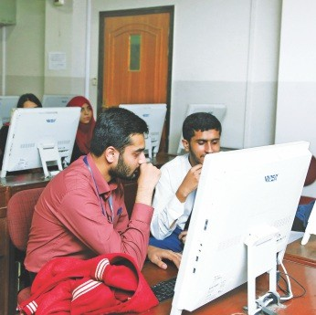

Partnerships and Collaborations (National)
  - Syed Babar Ali School of Science and Engineering (SBASSE), Lahore U n i v e rs i ty o f M a n a g e m e n t Sciences(LUMS), Lahore
  - U.S. Pakistan Centre for Advanced Studies in Energy (US PCASE), National University of Science andTechnotogy,lsamabad
  - S i n o - Pak Cen tre of A rtifi cial Intelligence (SPCAI), Pak-Austria Fach h o ch sch u ie I n stitu te of Applied Sciences and Technology (PAF-IAST), Haripur
Department of Materials Science and Engi neeri ng, Institute of Space Tech nology, Islamabad
- Tesla Industries (Pvt) Ltd
- Strongmen Industries (Pvt) Ltd
- OMECTA International(Pvt) Ltd
- F a i s a l d b a d C h a m b e r o f Commerce and Industry (FCCI), Faisalabad
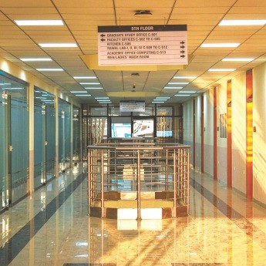

FAST-NUCES
Research Centres

Partnerships and Collaborations (International)
  - Ba tte ry Te ch n o logy Ce n t re, Samsung SDI America Inc.
  - Department of Ch em ical d nd P e t r o I e u m E n g i n e e r i n g , University of Calgary, Cdnada
  - State Key Laboratory of Advanced Electromagnetic Engineering dnd Technology(AEET), HUST, Chind
Dr. Muhammad Shoaib Khalid Professor, EE is Head of the CARE Research
- Advanced Control Systems

(ACS) Lab
Dr. Arslan Ah med Amin Associate Professor (EE) leads the Advanced Control Systems (ACS) lab in FAST NUCES CFD Campus and is very much focused on developing advanced co n tro I algo rith m s fo r criti cal industrial applications suCh as fault-tolerant control for IC engines as these are some of the most used components as prime movers in the process industry. Moreover, modern applications such as electric vehicles and drones are also being researched from a reliability enhancement point of view. The challenging control problems are also being addressed for power and smart grid applications. More than 40 publications in reputed impact factor journals have been completed and many papers have been submitted that are currently under review. The vision is to become the best control system lab in the country with aggressive research output and ample amount of funding fro m lo cal a s we I I a s fo re i gn universities.

Research Projects In-Progress:
1. Design of advanced fault-tolerdnt
control systems for autonomous vehicles and drones, 1.2 Million Rs. FAST NUCES FRSG 2023.

Completed:
- Applicatio n of Fault Tolerant control of Motors, Vehicle, and drones 12000SAR
- A p p I i c a t i o n s o f A rt i fi c i a I Intelligence in Fault- Diagnosis and Fau It-Tolerant Control for Industrial Applications Funding Age n cy: N a j ra n U n i ve rs i ty, E l e c t r i c a I E n g i n e e r i n g Depdrtment, Kingdom of Saudi Arabia: 50,000 SAR
- P e rfo r m a n c e , S a Ie ty, d n d Re I i a b i I ity E n h a n c e m e n t of I nd u striaI Ap pI icatio ns using Advanced Control Systems Te ch n iq ues, Fu nd i ng Agen cy: N aj ran U n ive rs ity, Electri cal E n g i n e e r i n g D e p a r I m e n t, Kingdom of Saudi Arabia: 50,000
SAR
D e s i g n oI A d v a n c e d Fa u it-Tolerant Emergency Breaking with Sensor Fusion
- Remaining Useful Life Prediction of Induction Motor Using Artificial Neural Network and loT
- Design of Active Fault-Tolerant C o n t r o I f o r F o u r W h e e I I nde pendently Driven Electric Vehicle Drive System by Fuzzy Neural Network

Dr.Arslan Ahmed Amin
Associate Professor, EE is Head of the
(ACS) lab

Sustainable Solutions Lab

(SSL)
The Sustainability Solutions Lab (SSL) aims to provide students with an e x p e r i e n c e o f p r o Ie s s i o n a I d eve lo p m e nI wh i ie wo r ki n g o n su stai n ab i lity-ori e nte d resea rch p roj ects, especi ally relate d to P a k i s t a n e I e c t r i c a I p o w e r infrastructure.
I n SSL students are working with faculty, staff, and field experts to define and solve some of our greatest challenges faces by th e c u rrent electrical power infrastructure of Pakistan.

Ongoing funded research

project
Designing of d relidble and resilient frd mewo r k: A ro dd m dp to n ext generdtion sustdindble solutions for P d k i s t a n e I e c t r i c a I p o w e r infrastructure (0.9 million PKR).

Main theme of the funded Int research project
Due to Pdkistan frdgile electricdt Title power infrastructure, dny unexpected event, i.e., tech ni CdI fd U It Ca USeS severe damage to power grids that can lead to a complete blackout. Therefore, deSigning d resilient and reliable power system network is an inevitable requirement for Pdkistan electrical power infrdstructure. This research project investigates the effect of thèse unexpected events on the power system network based on the re cent b lacko ut in Pak i std n electricdl power infrastructure. For example: A recent technicdt fault that occurred dt the Guddu power plant triggered a sud den d rop i n the frequency of power systems th at tedds d Chain redction in the form of CäSCdding faitures dnd subsequently shut down VdFious power plants in P a k i s t a n e t e c t r i C d t p o w e r infrastructure, chokÏ kg dbout 10,320 megdwdtts of electricity. Considering this scenario, the major contribution of this research p roj ect wi ll be designing a retidbve and resilient power system that integrates phdsor meas u re ment u n its ( PMU s) an d d i str i b u te d u n ifie d p owe r flow controller to provide stabitity to the etectricat power infrastructure of Pakistdn in cdse of these unexpected events.

Dr. Muhammad Adnan
Associate Professor, CE is Head of the SSLLab.


Prospectus 2025

FAST-NUCES
Research Centres

Research Group: Signal Processing and Control Theory
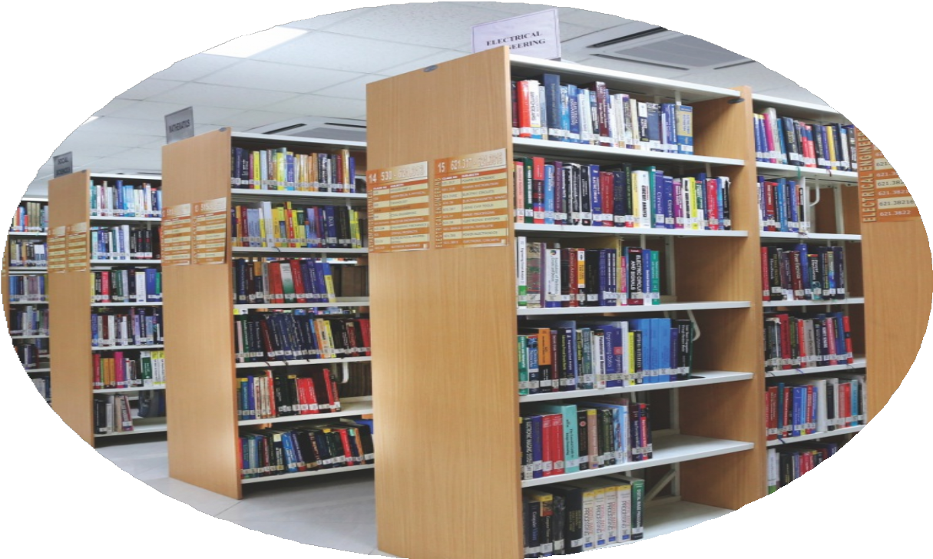
The Signal Processing and Control Theory research group focuses on a d V d n c i n g t e c h n i q u e s a n d methodologies in two critical areas of m o d e r n e n g i n e e r i n g. I n S i g n al P rocessi ng, th e grou p exp lo res systems ana lysis, transform, and extract information from signals in v a r i o u s d o m a i n s , s u c h a s c o m m u n i c d t i o n , b i o m e d i c a I engineering, and networked control systems. The research explores into a re a s I i ke d i gital filie r d e sig n, ad aptive sign al p rocessi ng, d ata c o m p r e s s i o n , a n d p a t I e r n


Prospectus 2025
recogn ition, with applications in areas such as speech recognition, image processing, and real-time data analytics. The group aims to push the boundaries of how signals can be efficiently processed and used to extract actionable insights in both n oisy and clean environments. I n Control Theory, the research group investigates new methods for the design and ana lysis of dynamic syste m s e s p e c i a I ly t i m e - d e lay systems to achieve desired behaviors such as stability and stabilization in response to external inp uts. This includes research in robust control, adaptive co ntrol, and networked control to ensure stability, optimality, and precision in various real-world systems. Applications range from
robotics and autonomous vehicles to p owe r syste m s a n d i n d u stri al auto m atio n. By i nte grati n g th e principles of signal processing and control theory, the group seeks to s o I v e c o m p I e x p r o b I e m s i n automation, communication, and i n t e I I i g e n t s y s t e m d e s i g n , contributing to advancements in fields such as aerospace, healthcare, and smart infrastructure.

Research Group Members
- Dr. Adil Zulfiqar
- Dr. Muhammad Adnan

Dr. Adil Zulfiqar
Associate Professor, EE is Head of the Signal Processing and Control Theory

